Index No. _________

MILITARY COLLEGE OF SIGNALS
FINAL EXAMINATION – Multivariable Calculus
(BESE – 15)

Instructor: Dr Saeed Murtaza Date: January 2011.
Max Time: 150 min Max Marks: 50
Note
- Attempt all questions in the given sequence.
- Understanding question is the part of examination.
- Show complete working, i.e., do not leave any thing for the instructor to assume on your behalf.
- There are no marks for the procedure only.
- Attach question paper with the answer sheet.

Q. No. 1:
- What do you understand by the terms “initial conditions” and “boundary conditions”?
- If you have to find a particular solution for the following PDEs, how many initial and boundary conditions will be required? Justify your answer.
(a) 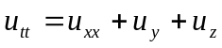 (b) 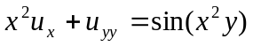
[2+4]
Q. No. 2:
- Find the temperature 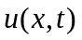at any time t, in a laterally insulated bar of length 10 cm, if one end of the rod is maintained at 10 ºC and the other end is maintained at 50 ºC. Given that the initial temperature is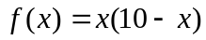.
- Sketch the initial and steady state temperature.
[6+4]
Q. No. 3:
Consider the equation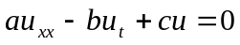where a, b, and c are constants.
- Substitute 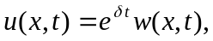where is constant, and find the corresponding partial differential equation in terms of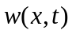.

- If 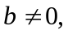 under what conditions on the partial differential found in part (a) will become the heat equation, in terms of 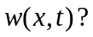
[3+2]
Q. No. 4:
Set up iterated integrals to find the area of region bounded by 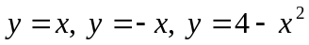and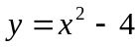. Do not evaluate.
[5]

P. T. O.

Q. No. 5:
- What is the physical significance of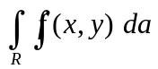?
- Evaluate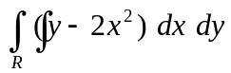, where R is the region inside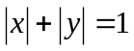. Reverse the order of integration and evaluate once again. Compare both answers, how will justify your answers?
[3+3+2+2]
Q. No. 6:
Evaluate 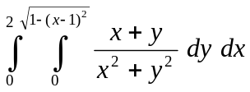
[4]
Q. No. 7:
Set up triple integrals in the orders 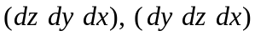and 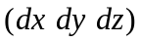to find the volume of the object given below.

[2+2+2]
Q. No. 8:
Evaluate
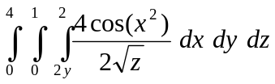
[4]

